[**Terraform - Getting Started**](https://app.pluralsight.com/courses/cc6552b7-fc1c-4dfe-a3f3-635c8a0c4528/table-of-contents)

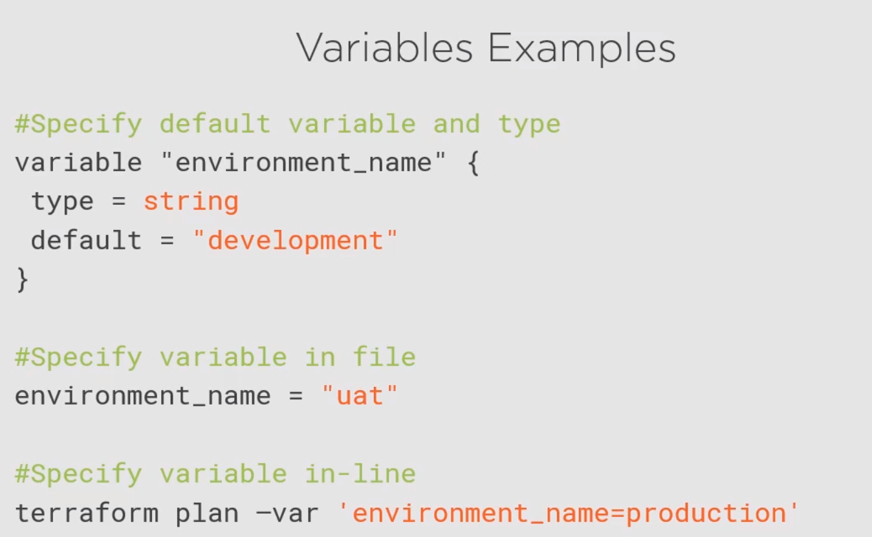

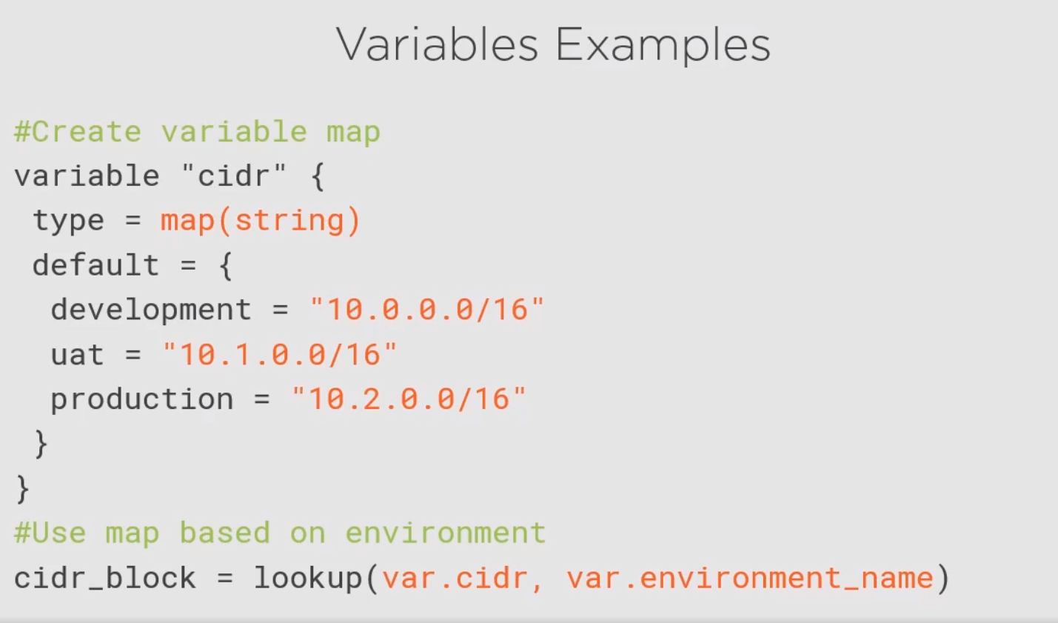

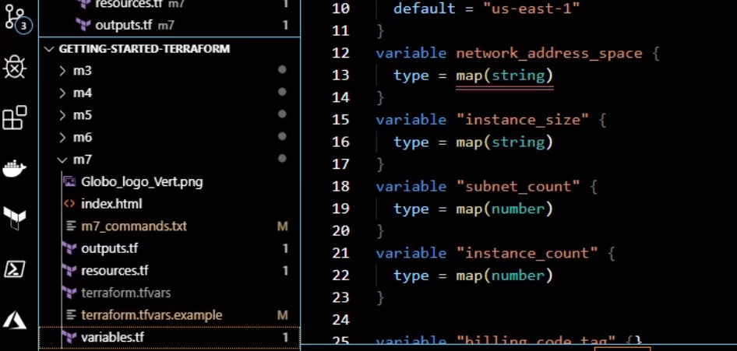

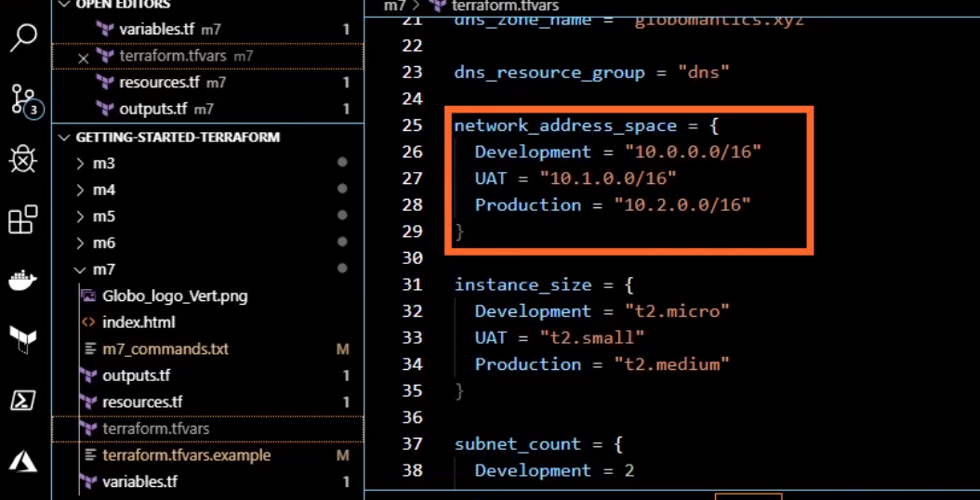

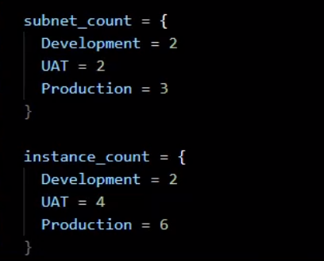

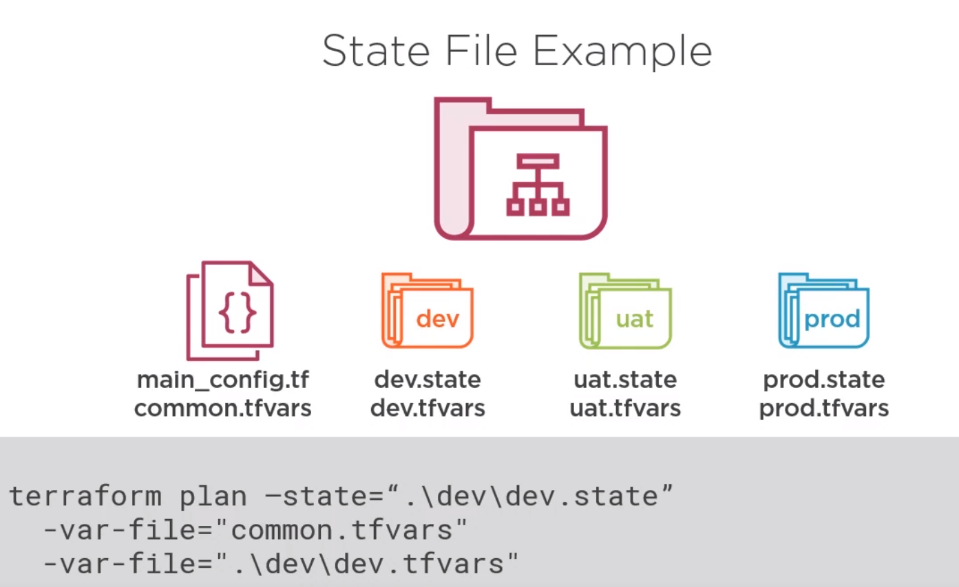

Manually managing the state

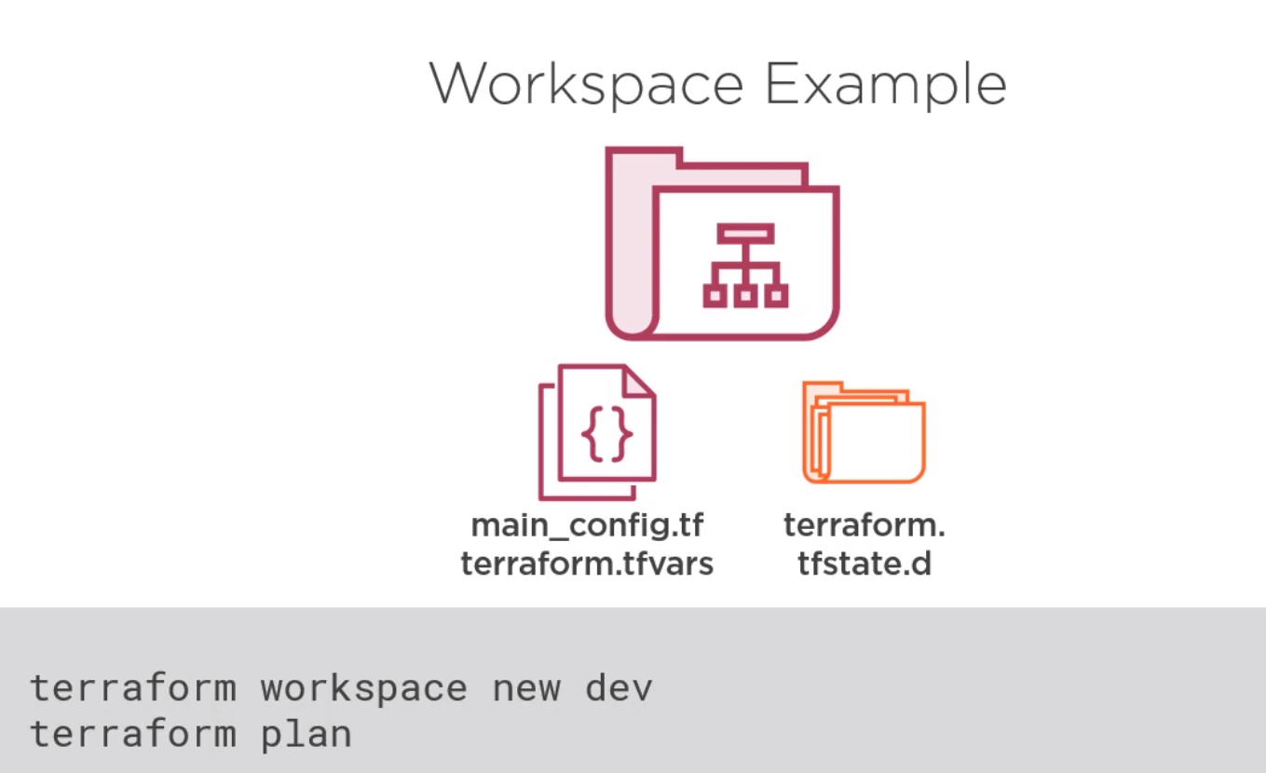

Terraform managing the state for you.

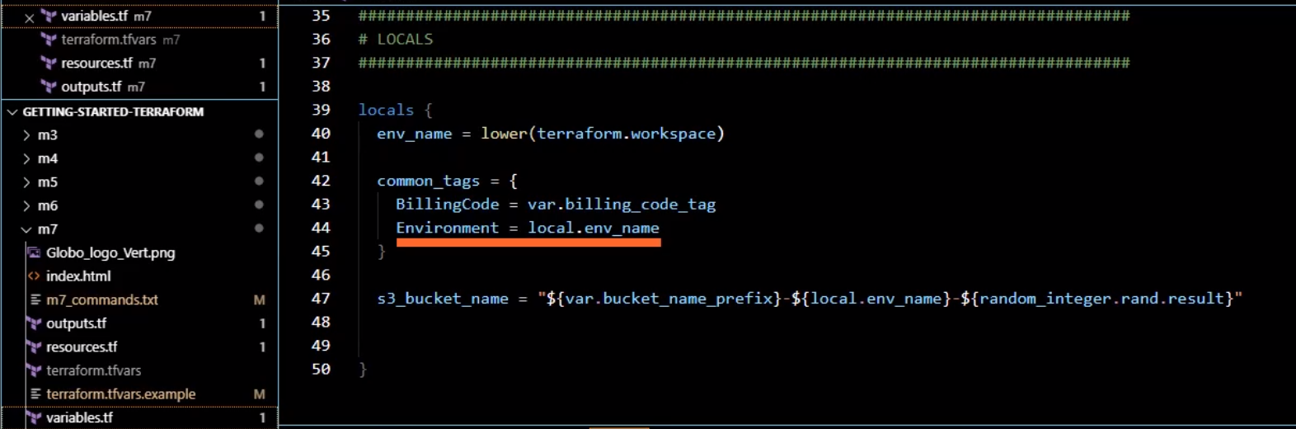

Store workspace in terraform.workspace

<https://github.com/ned1313/Getting-Started-Terraform/tree/master/m7>

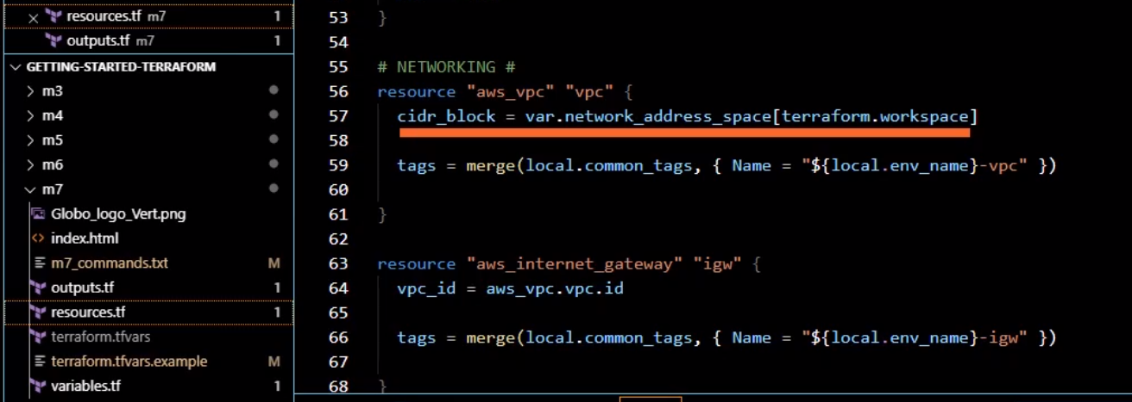

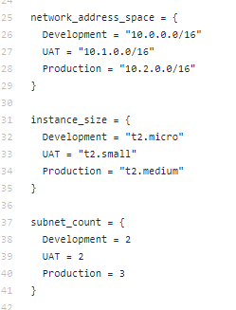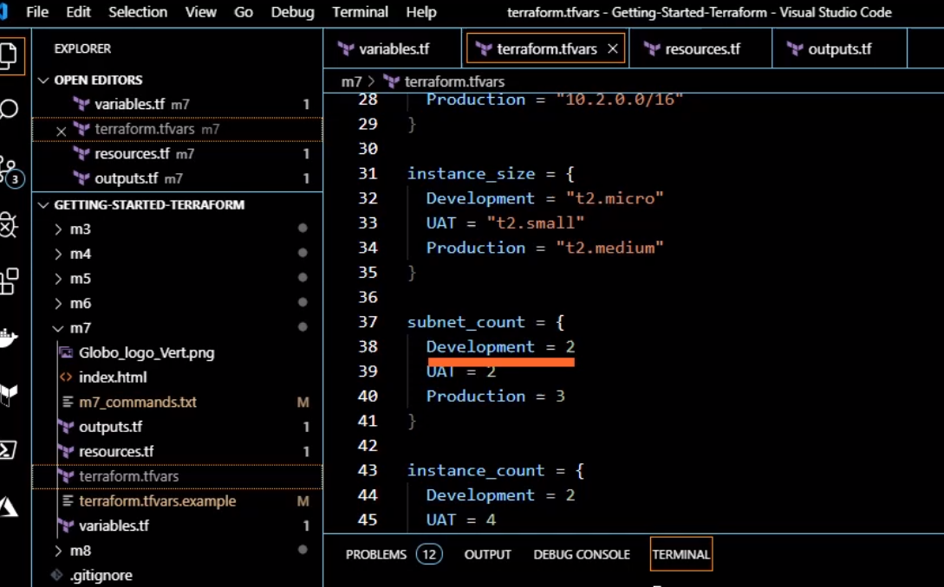

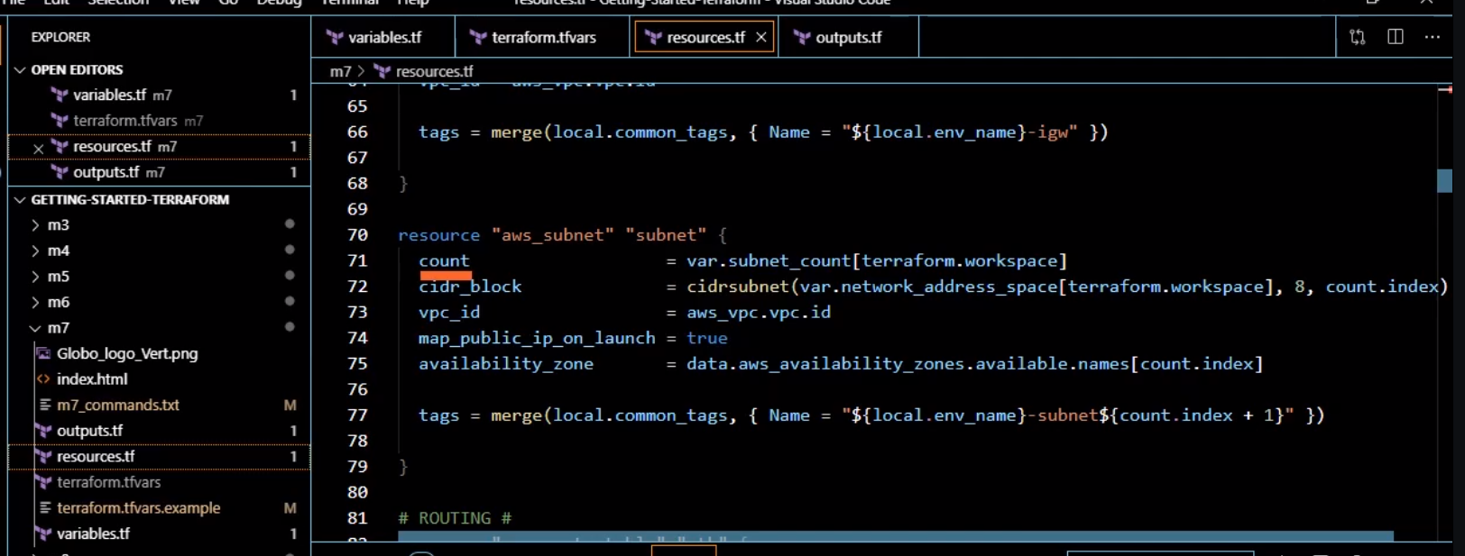

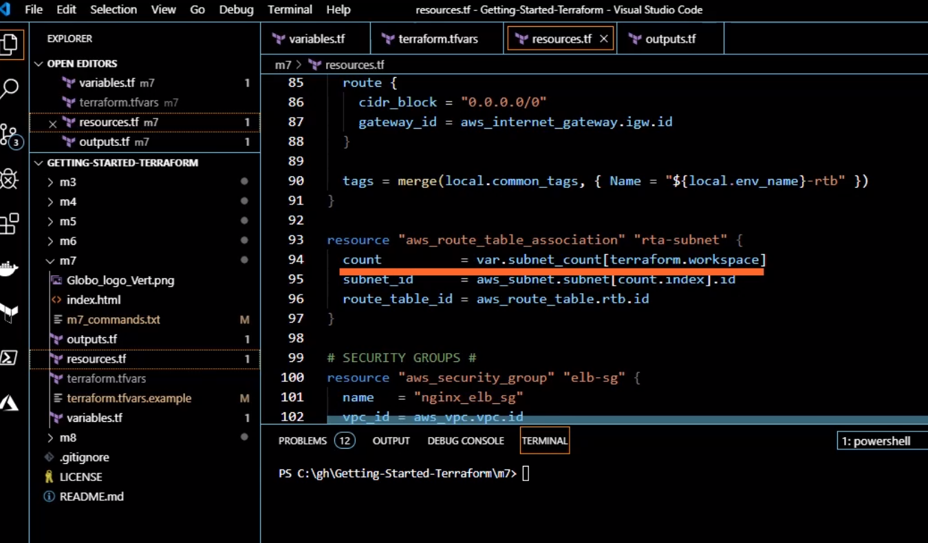

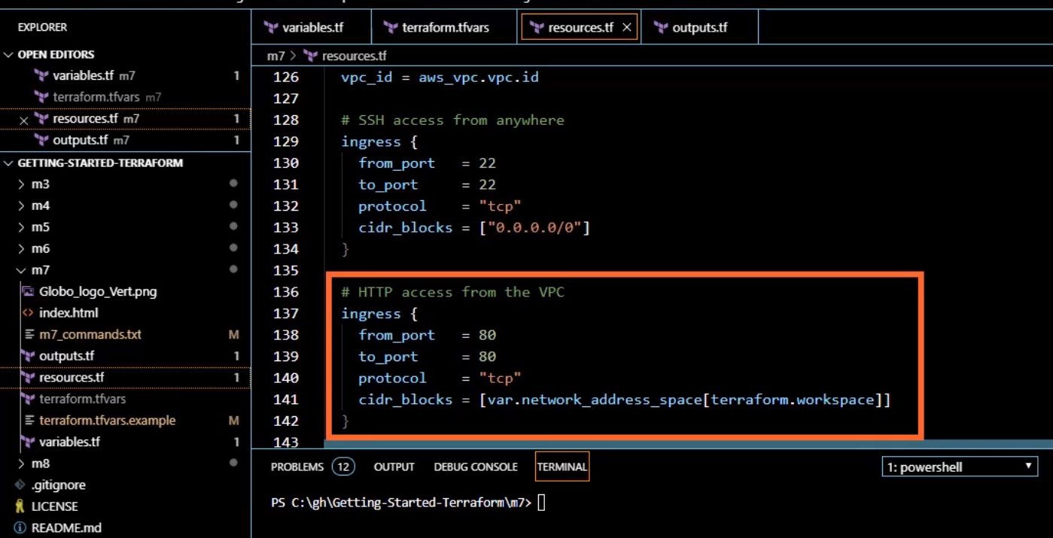

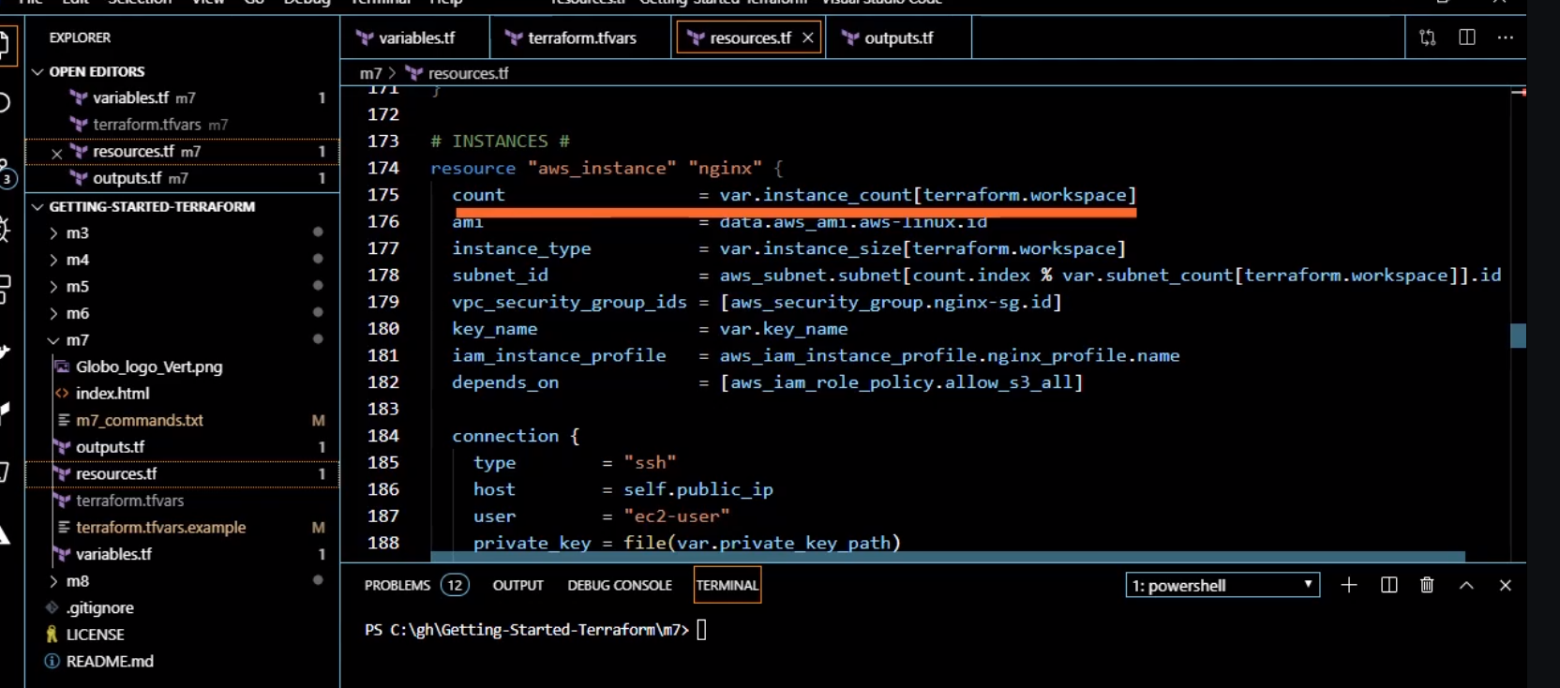

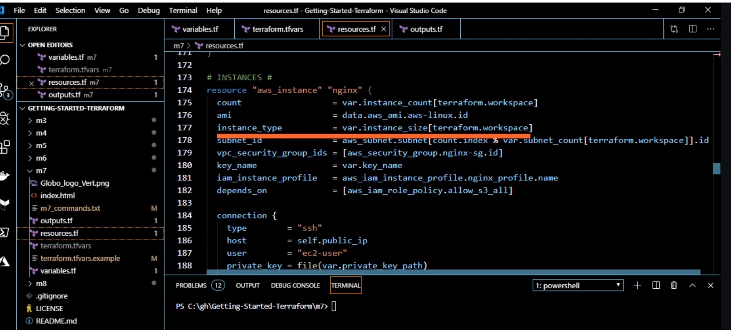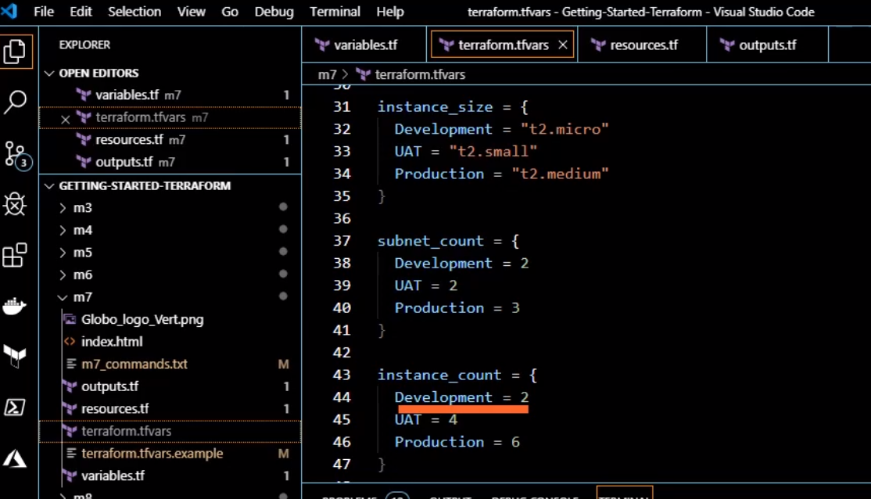

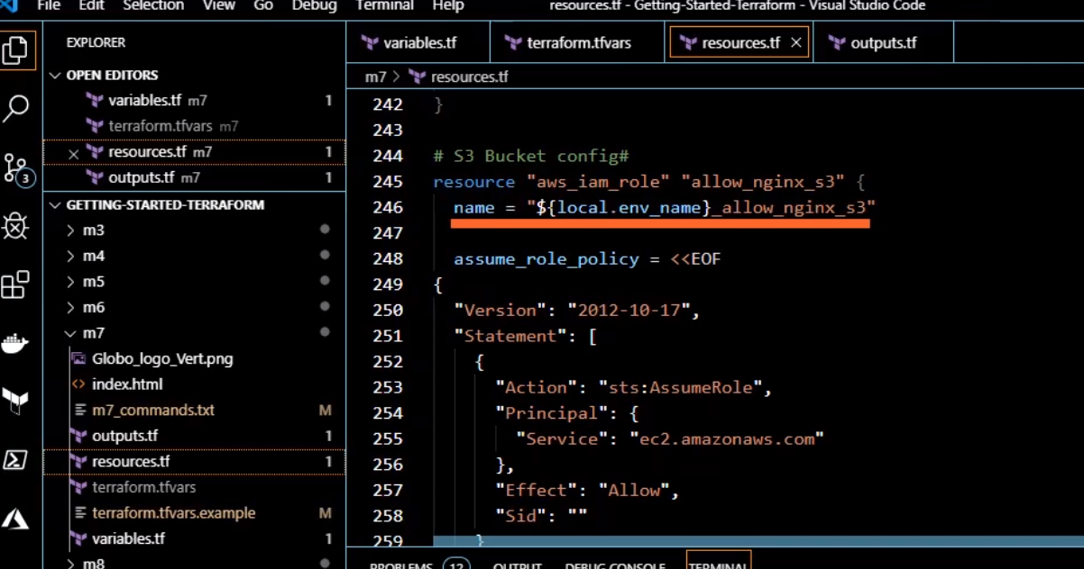

|  |
| --- |
| Terraform init |
|  |
|  | terraform workspace new Development |
|  | terraform plan -out development.tfplan |
|  | terraform apply "development.tfplan" |
|  |  |
|  | terraform workspace new UAT |
|  | terraform plan -out uat.tfplan |
|  | terraform apply "uat.tfplan" |
|  |  |
|  | #Don't forget to remove from tfvars, variables, and resource provider |
|  | $env:AWS_ACCESS_KEY_ID="AWS_ACCESS_KEY_ID" |
|  | $env:AWS_SECRET_ACCESS_KEY="AWS_SECRET_ACCESS_KEY" |
|  |  |
|  | terraform workspace new Production |
|  | terraform plan -out production.tfplan |
|  | terraform apply "production.tfplan" |
|  |  |
|  | terraform destroy |
|  |  |
|  | terraform workspace select UAT |
|  | terraform destroy |
|  |  |
|  | terraform workspace select Development |
|  | terraform destroy |

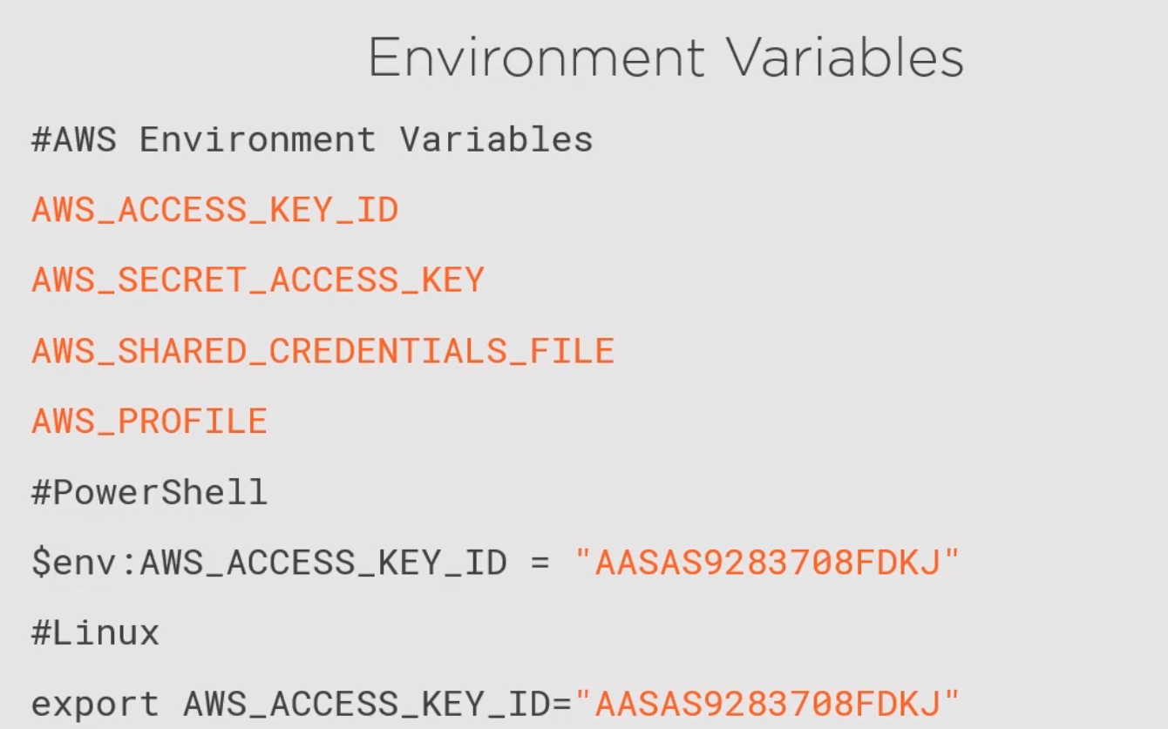

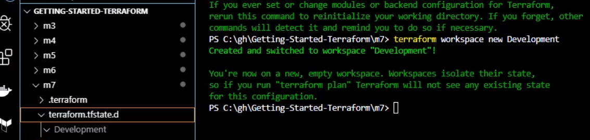

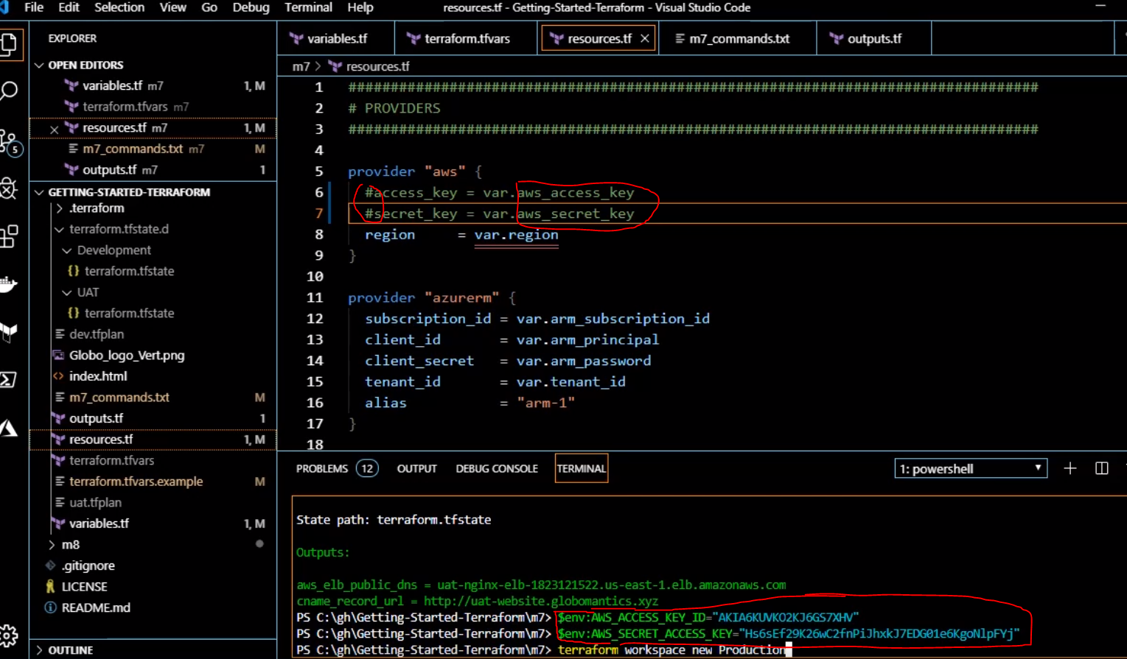





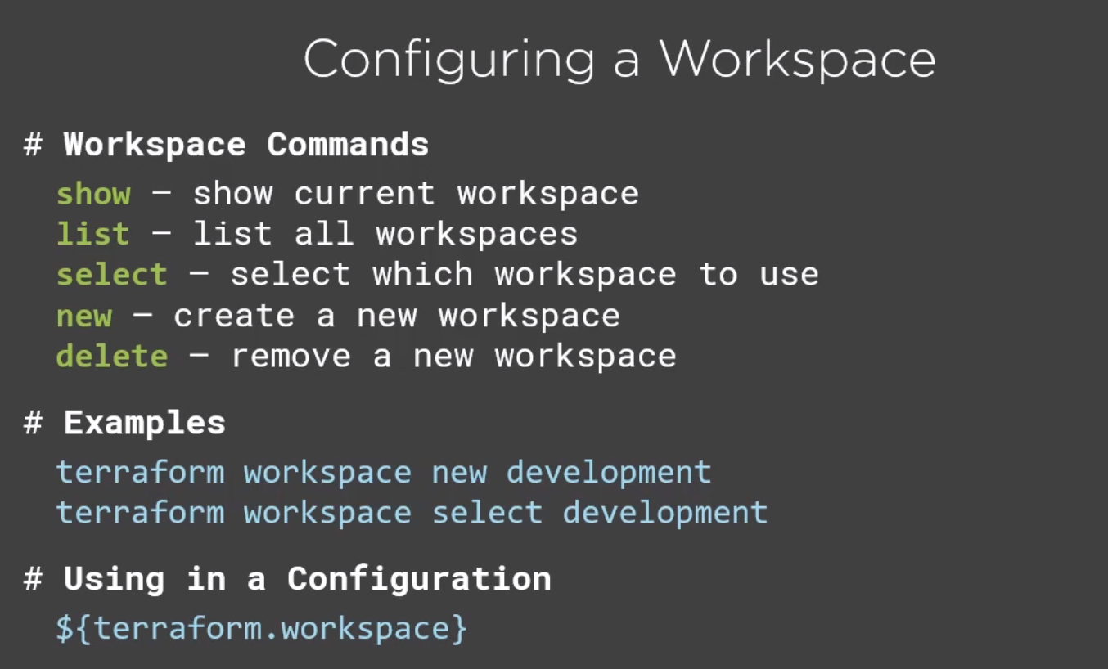

Terraform workspace new development

Terraform workspace show (show your current workspace)

Terraform workspace list

Run workspace:

Terraform plan –var-file=”..\..\..\terraform.tfvar” -out terraform-development.tfplan

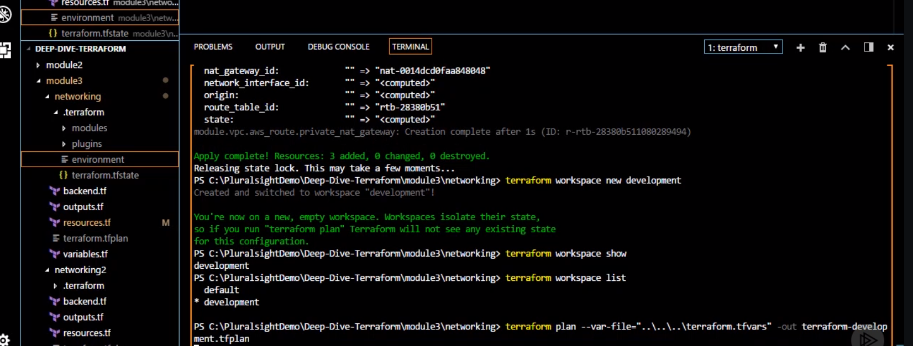

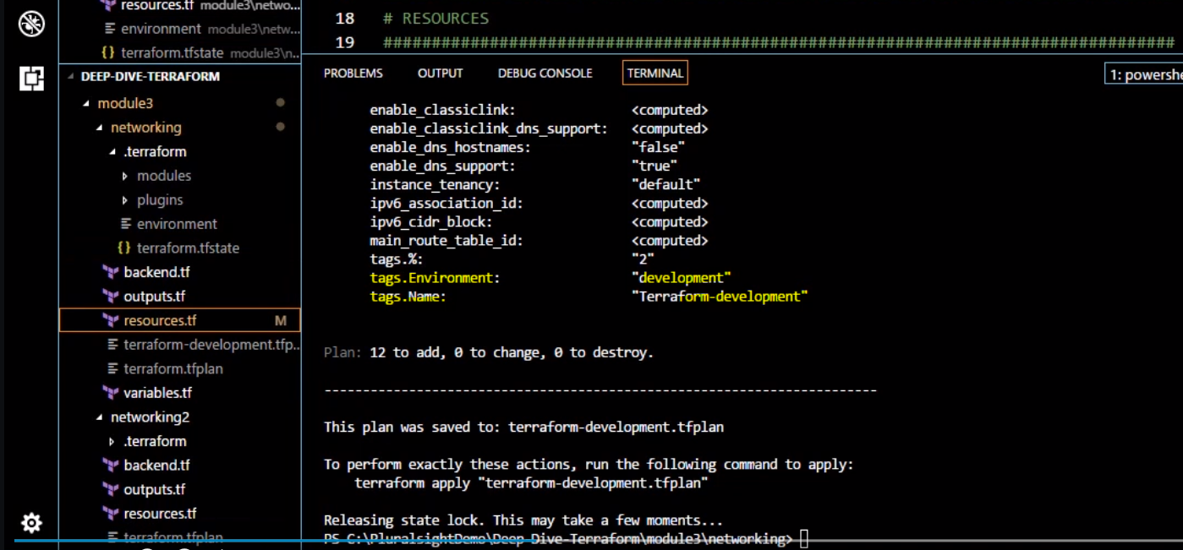

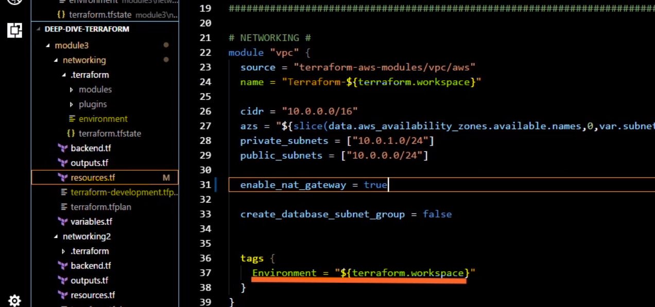



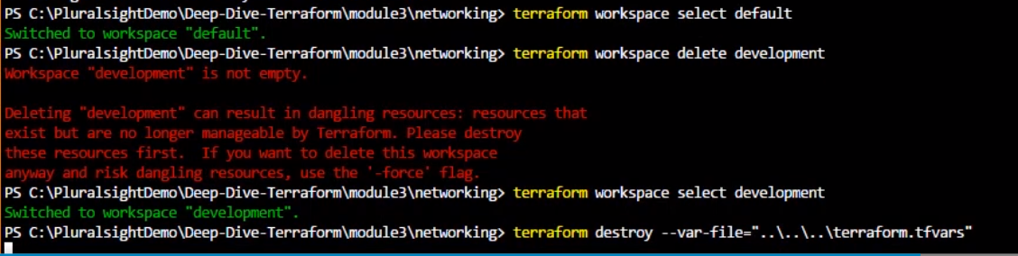

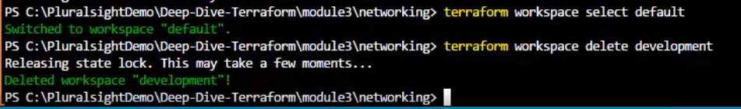

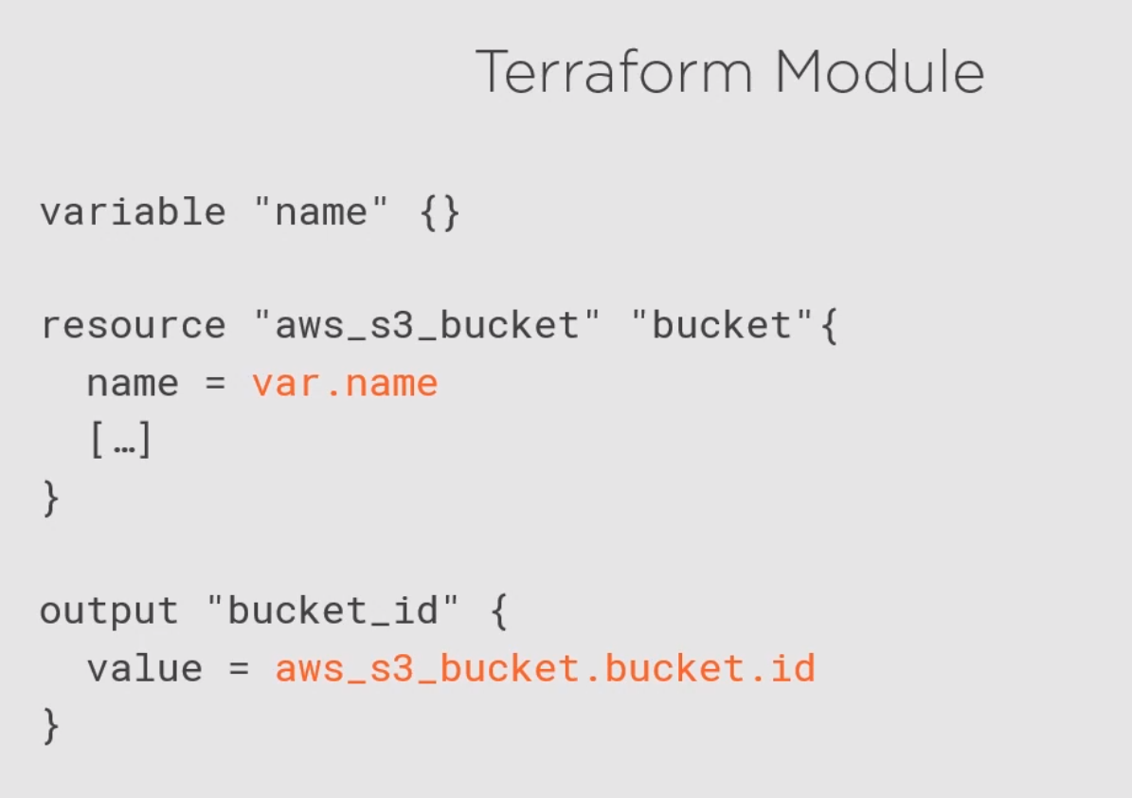

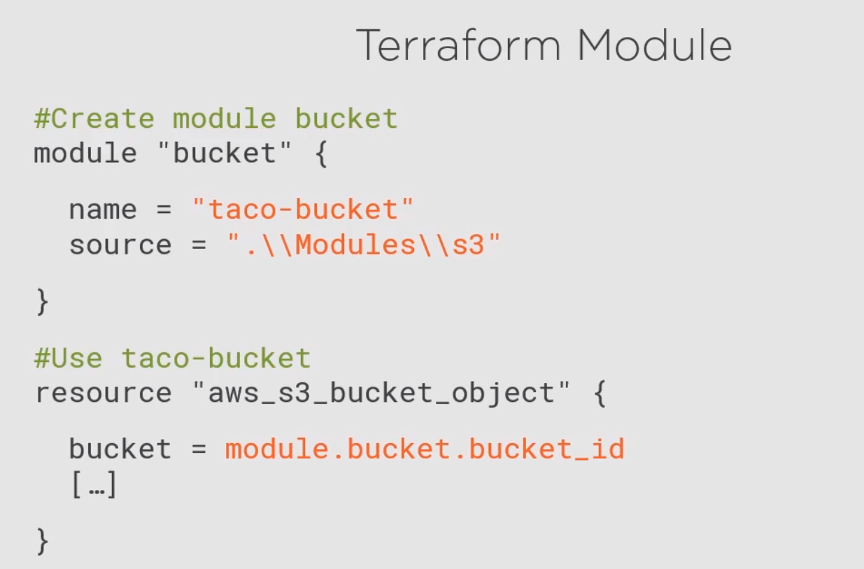

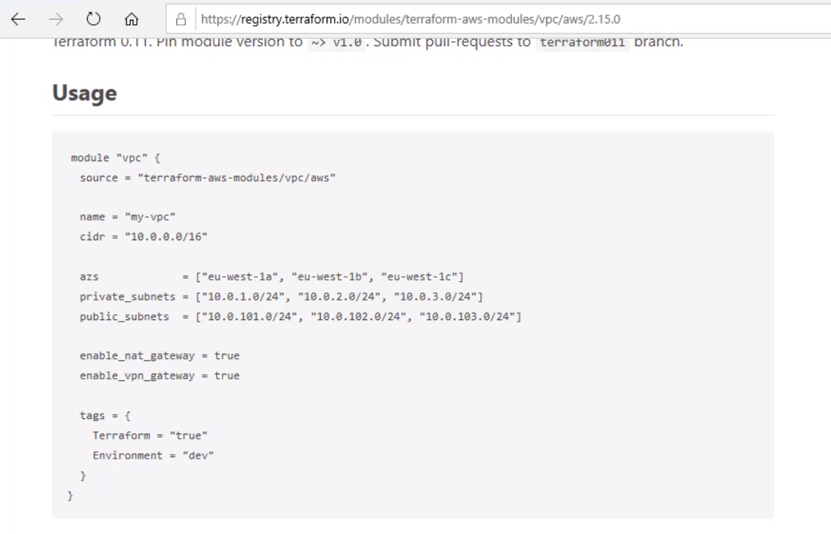

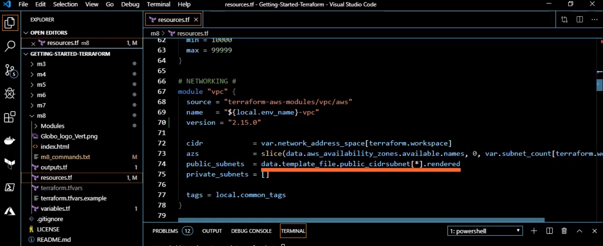

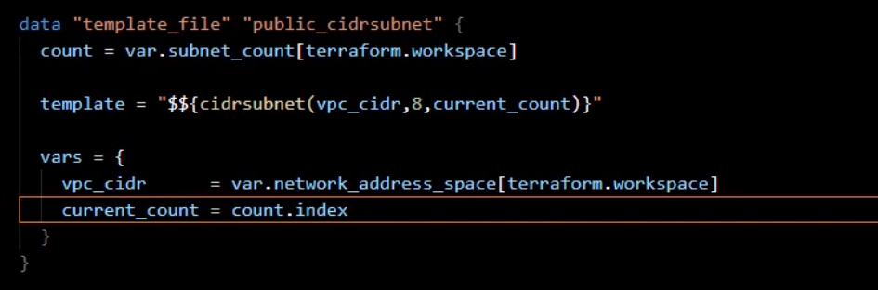

This template is in the advance class

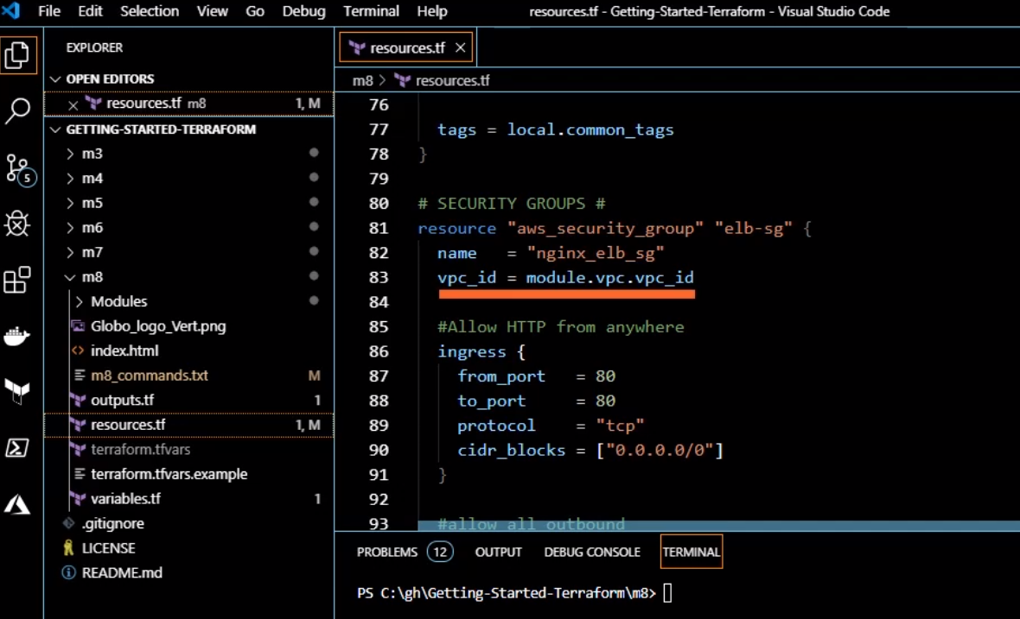

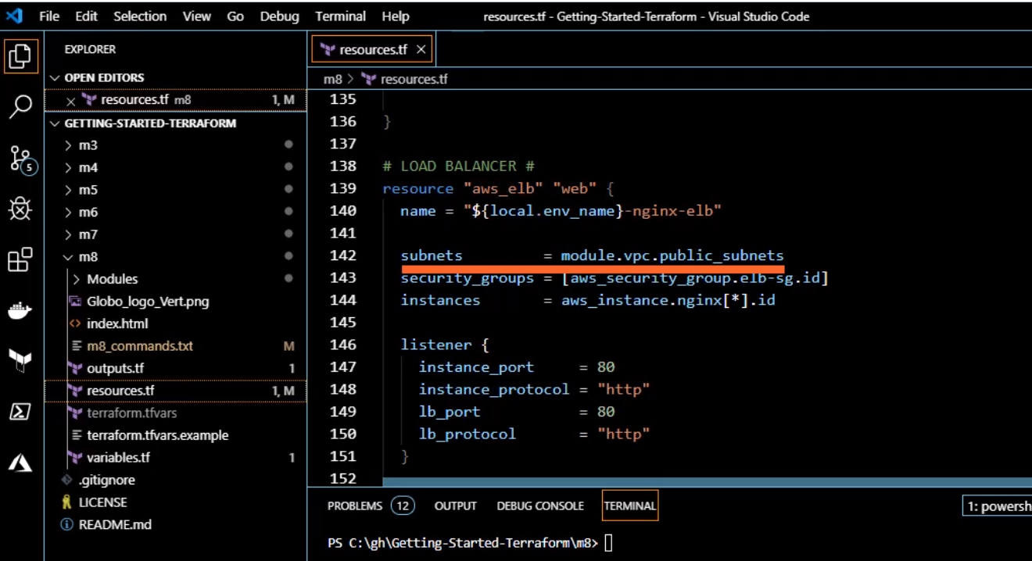

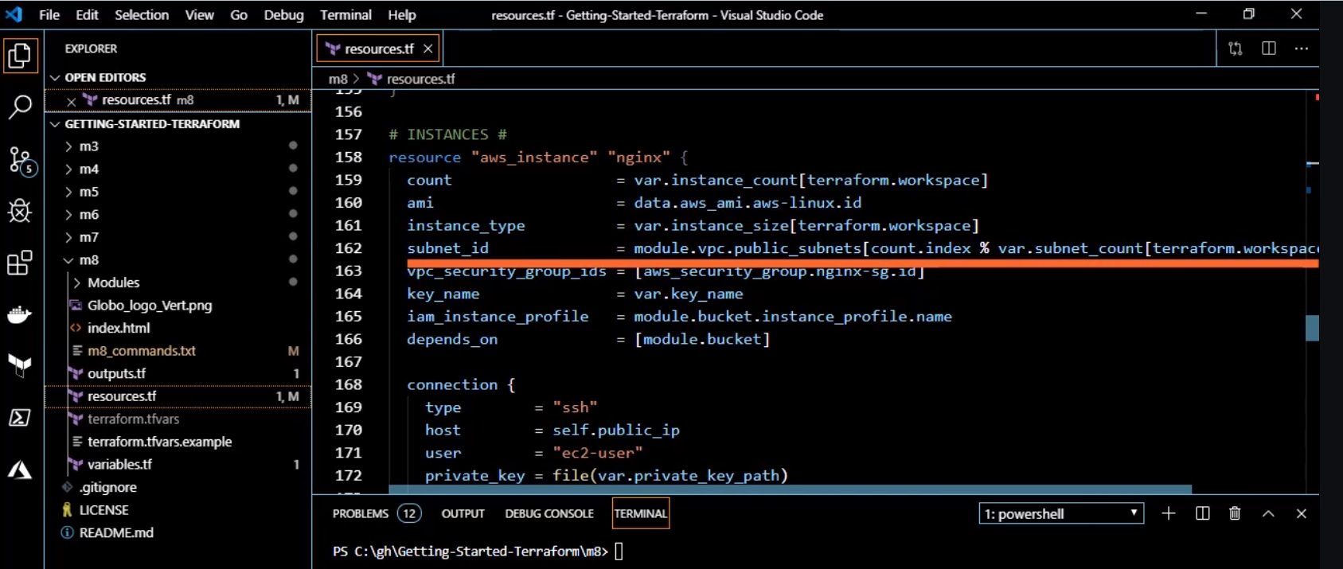

Consuming the module.

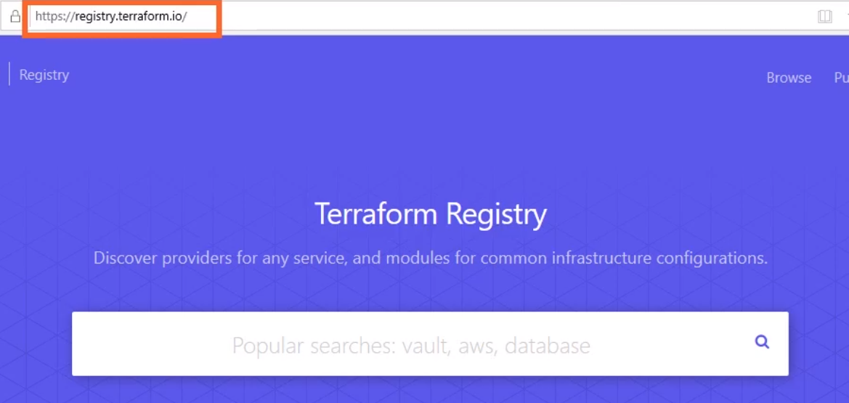

Above is the link to find other already defined modules

Already created modules from the vendor

Vsphere:

<https://registry.terraform.io/modules/Terraform-VMWare-Modules/vm/vsphere/0.10.0>

<https://github.com/Terraform-VMWare-Modules/terraform-vsphere-vm/tree/v0.10.0/examples/windows>

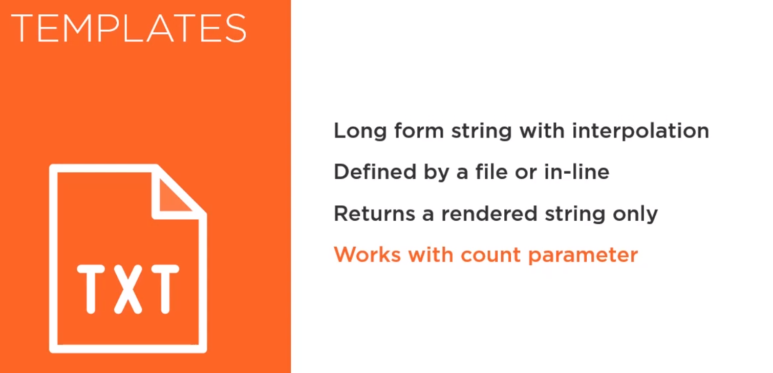

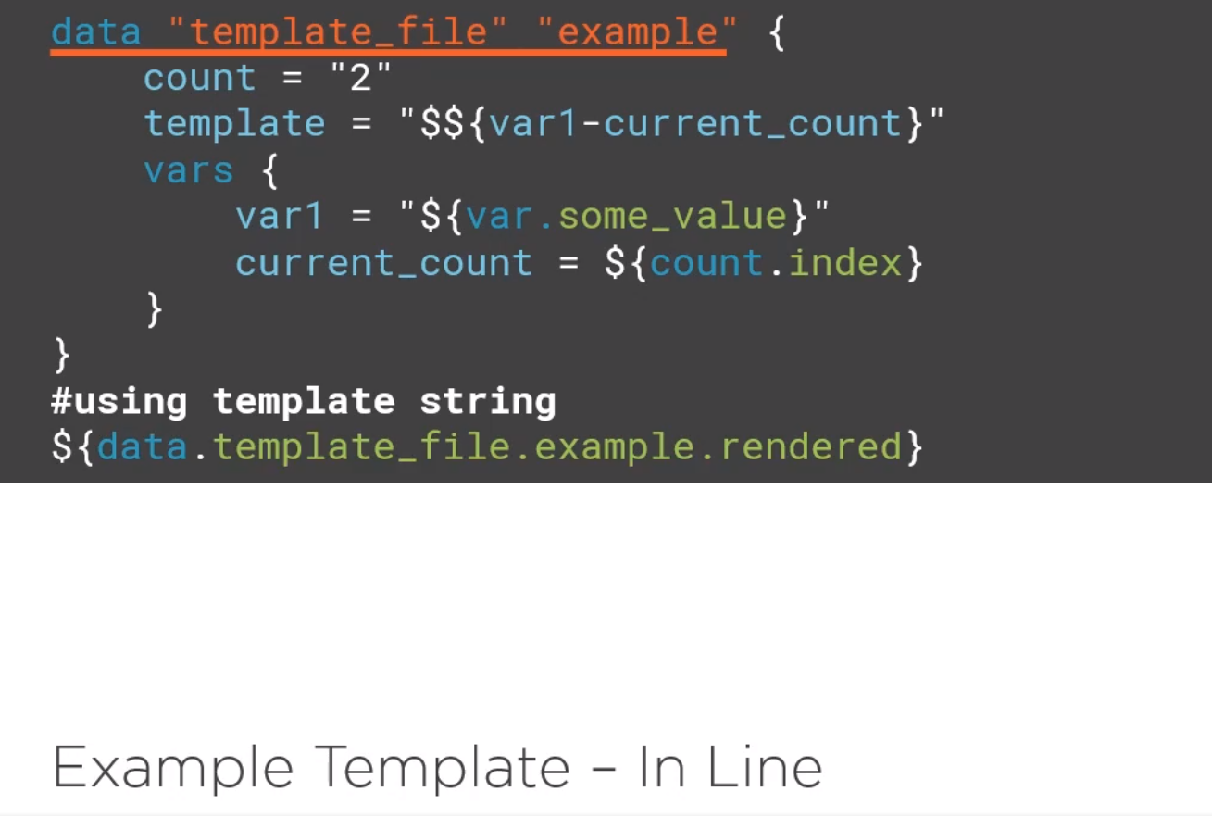

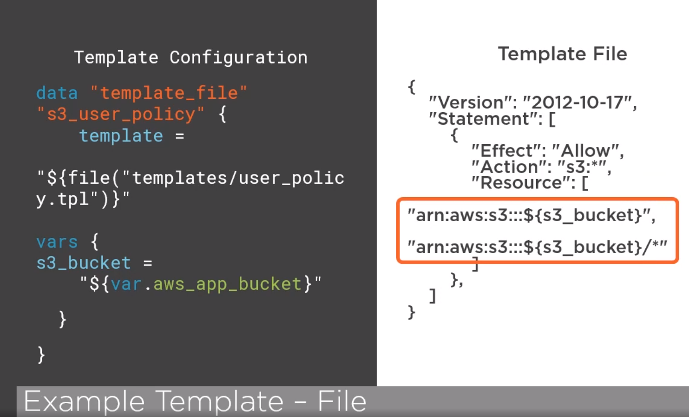

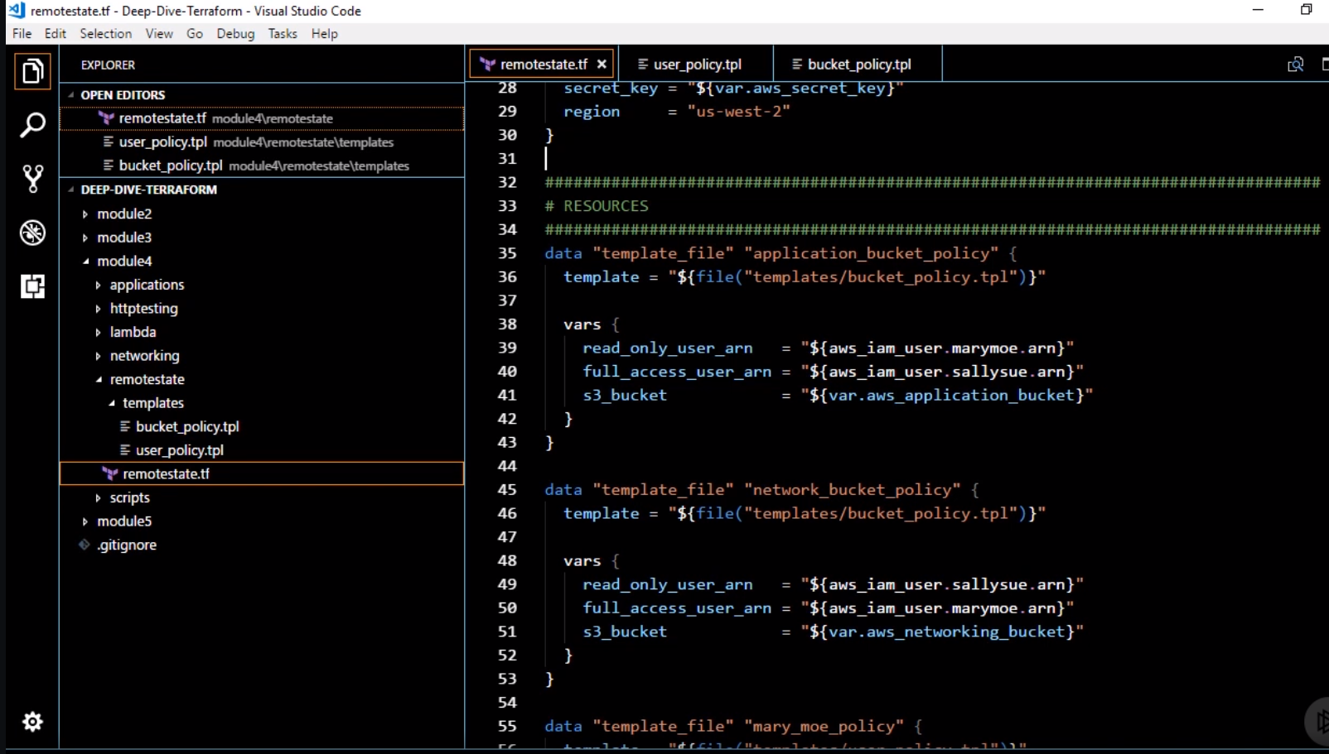

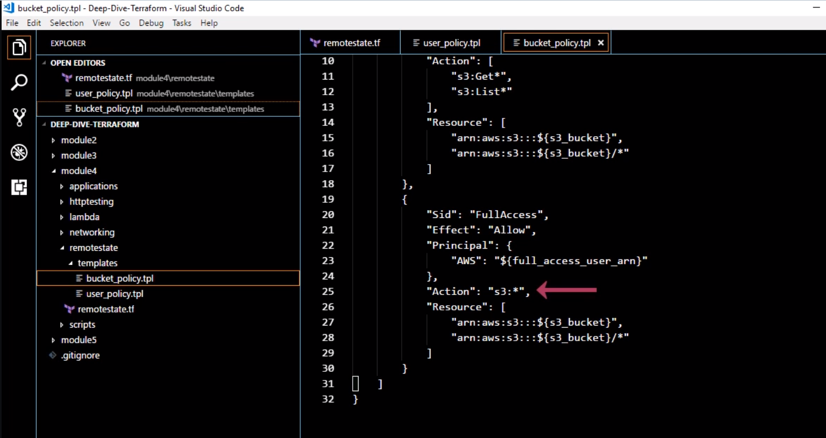

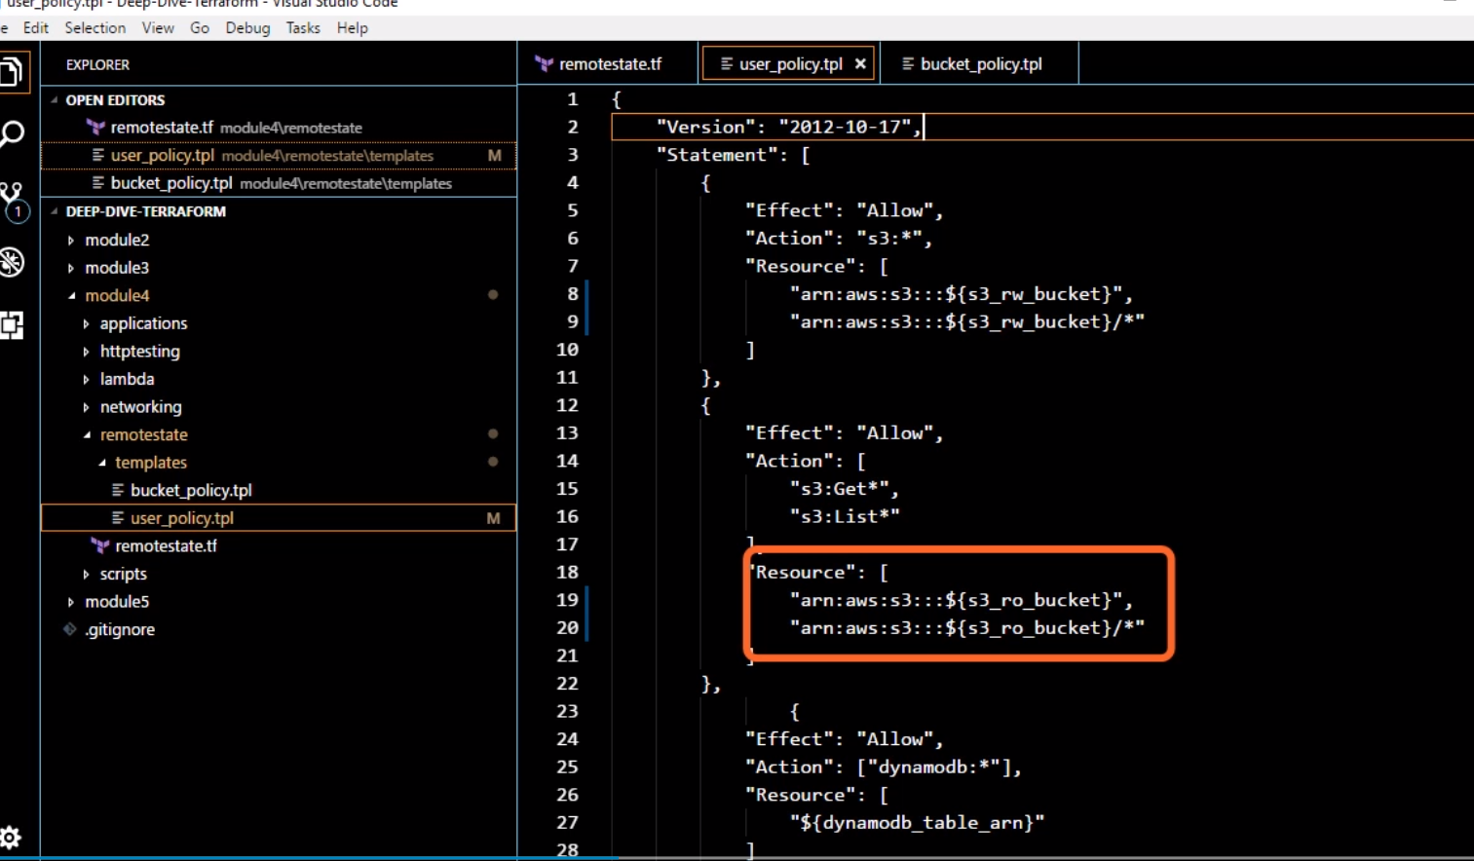

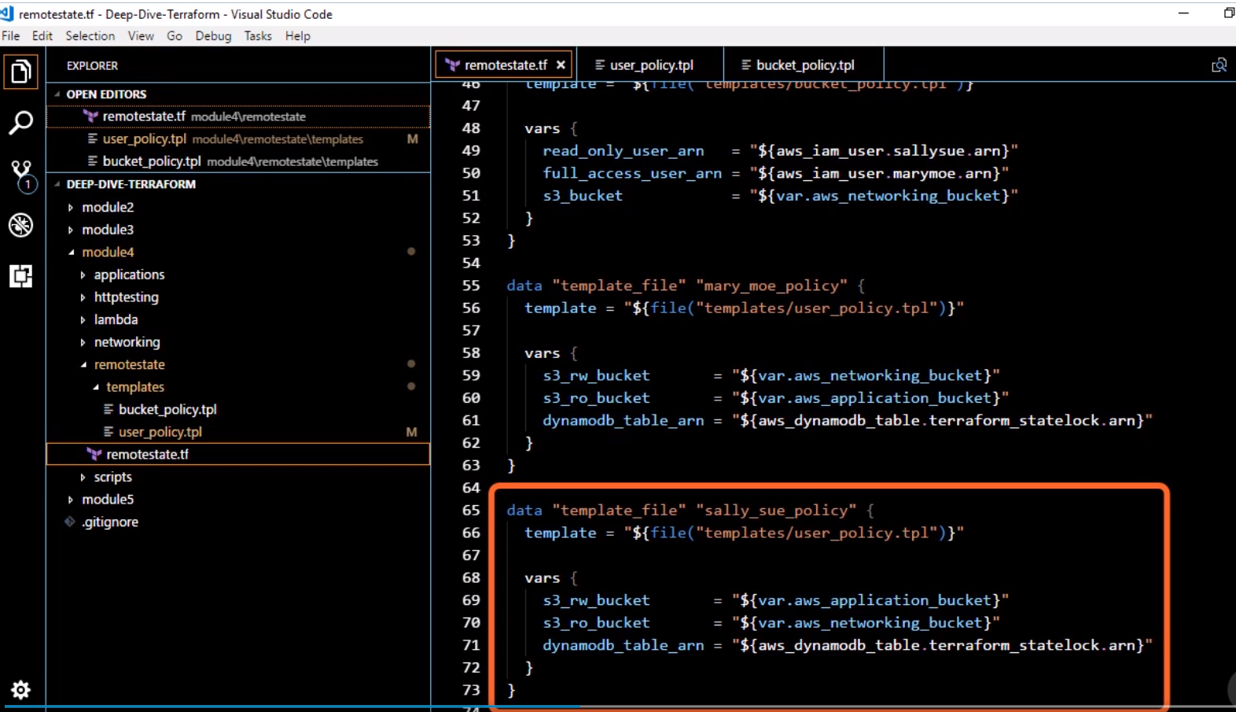

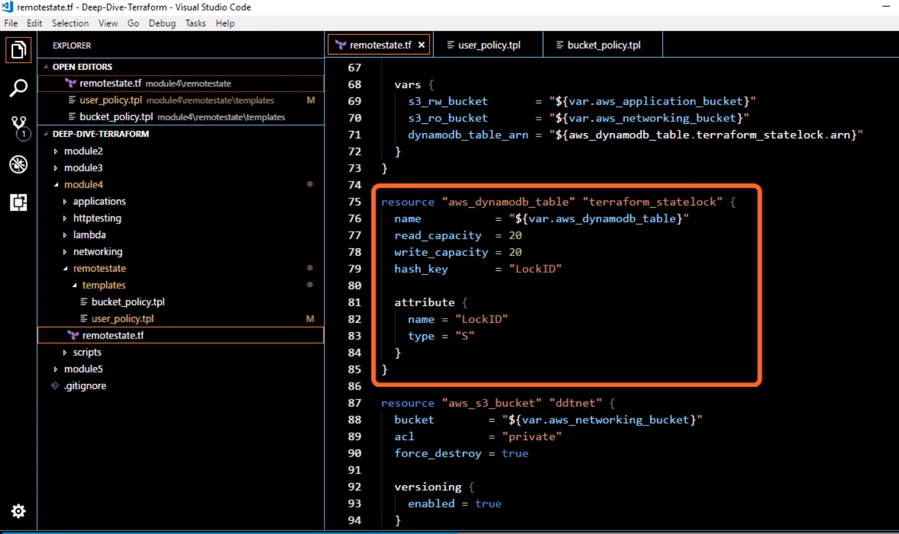

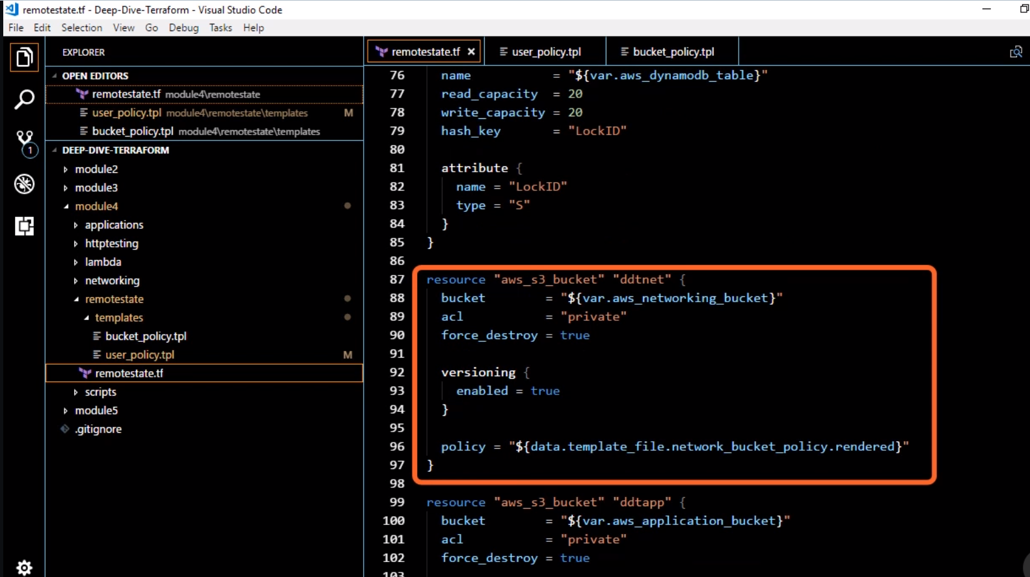

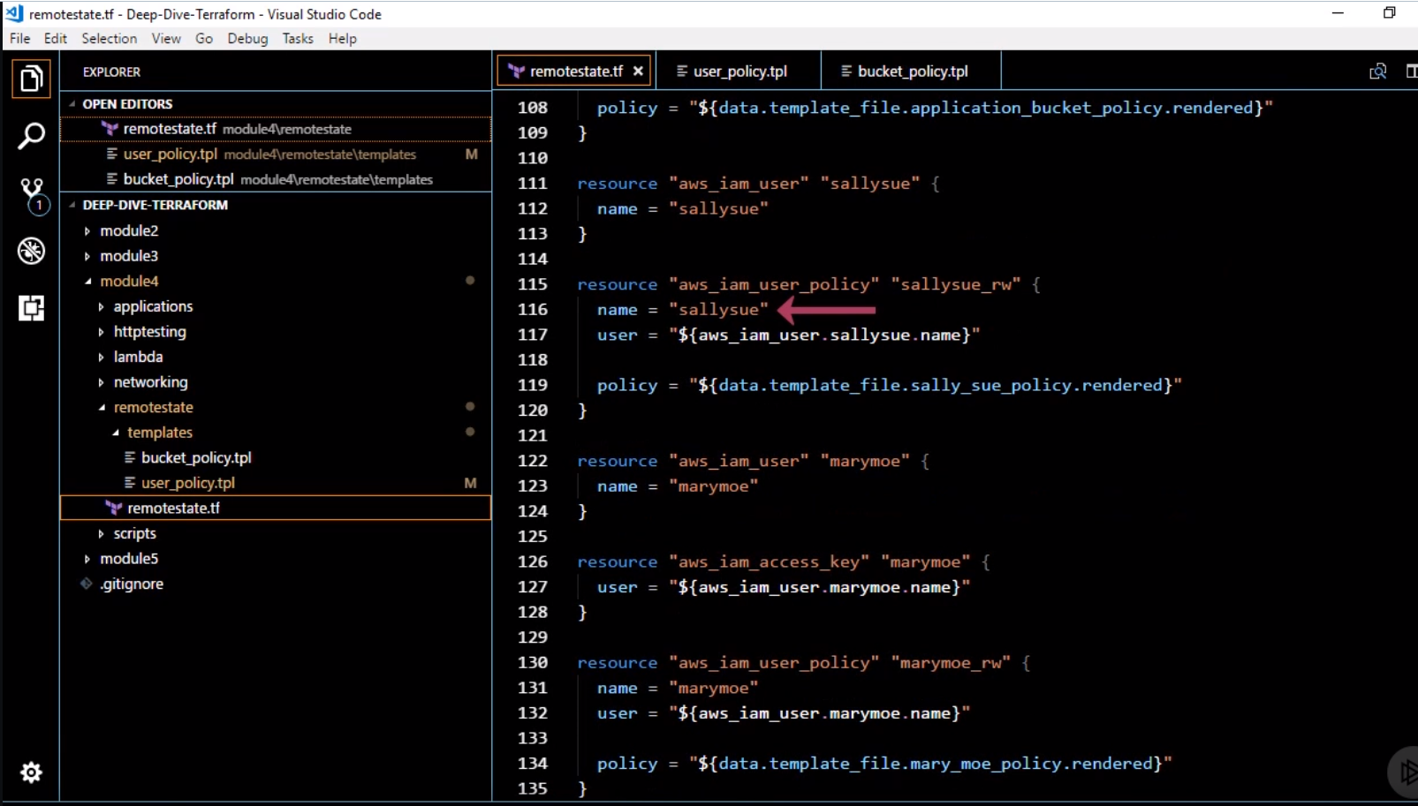

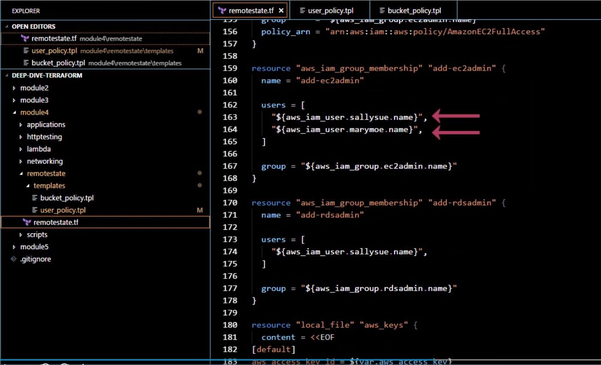

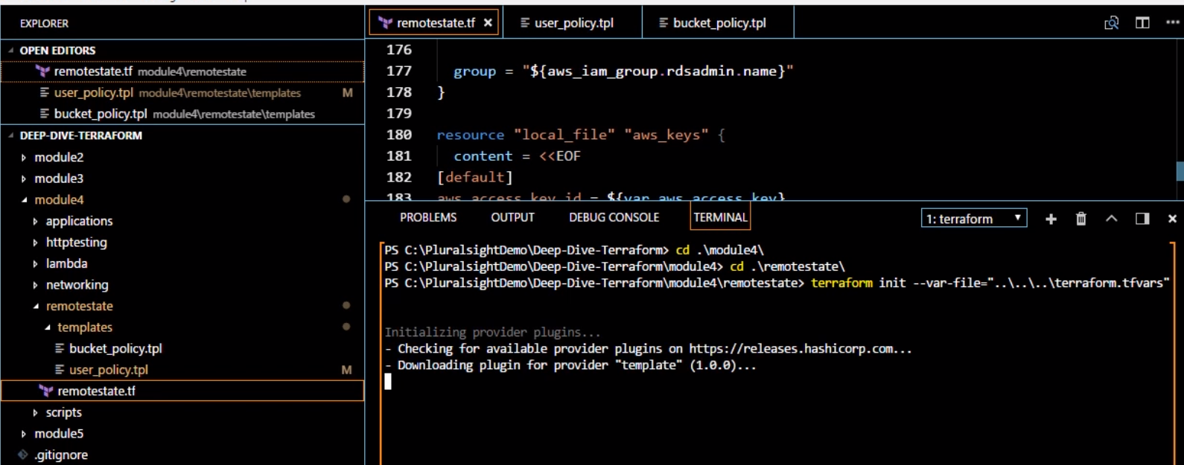





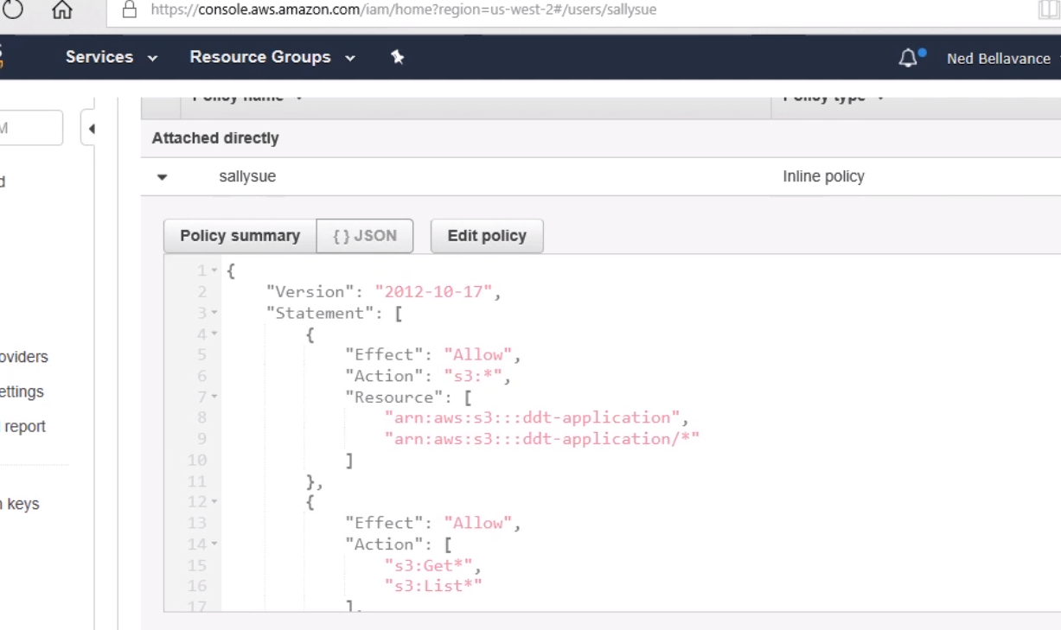

This policy was based off the template that we pass to it

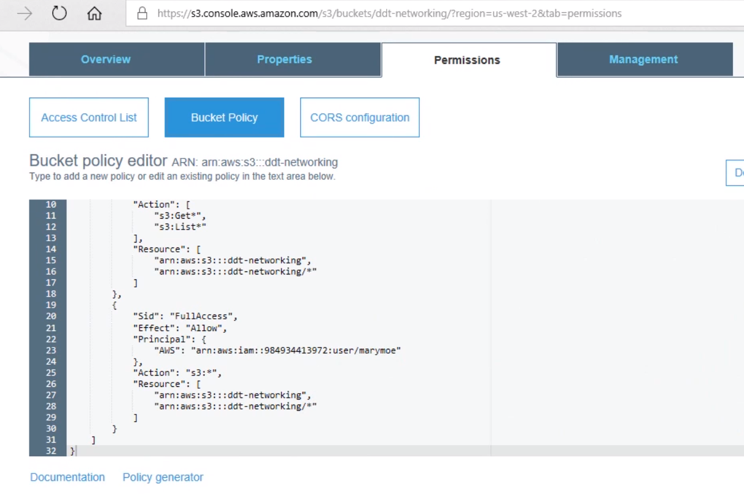

From the template file that we generated